Nama : Rizqi Ramadhani Abdillah Putri

NIM : 071911633005



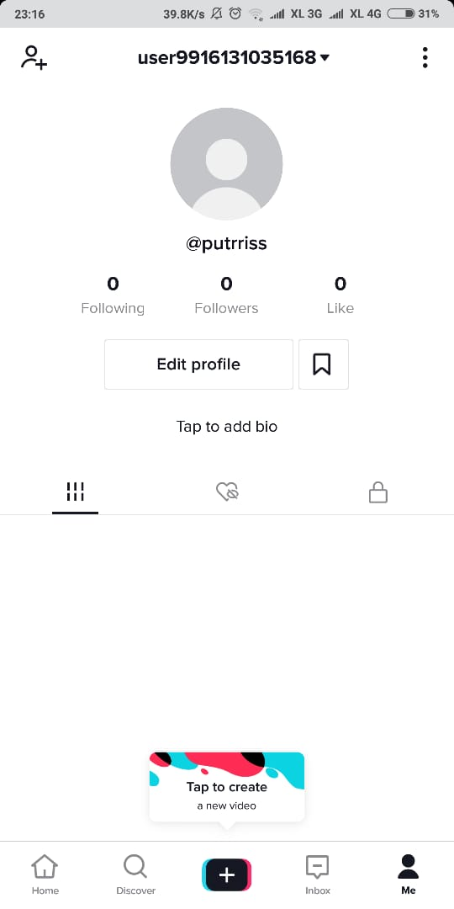

<https://www.instagram.com/p/CFAJNbtps2_/?igshid=1tvp4va73xr6o>